Happy New Year 2016!
We hope you had another healthy, prosperous and successful year!
Here is what’s new with us this year…..
appointments
Start making your Appointments now by
- By Email: info@quiktaxservices.com
- By Phone: 714-744-4077
*Any cancellations less than 24hrs may be charged $75
*Payment due at time of service - we accept cash, check, major credit cards (5% convenience fee)
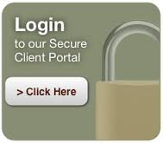
Client Portal
You can view, download, or upload any of your tax documents (Tax return, 1099s, W2s etc.)

QuikNet
Our community of small businesses. Anyone who is self-employed or has a service to offer, contact us to get you on the list.
Referrals
We appreciate and welcome your referrals! They have been the backbone of our business for over 20 years.

